How to Setup AN & Report DEV Environment

Revision History

|  |  |  |
| --- | --- | --- |
| Date | Author | Content |
| 07/15/2014 | Kenny Li | Initial. Set up for AN/CUI. |
| 09/03/2014 | Lester Li | Added setting up for Report |
| 09/23/2014 | Leon Chen | Remove the setting up for CUI part since there is a same document created by Rae. |
| 11/11/2014 | Wesley Wang | Add some solutions for regular error and details. |
| 11/25/2014 | Kenny Li | Change shared folder path from Kenny’s machine to server “Xian-acrora” |
| 03/06/2015  09/10/2015  10/16/2015  10/17/2015 | Lester Li  Bridget O’Flaherty  Nan Liu  Nan Liu | Add solution for error “The Web server does not appear to have the FrontPage server extensions installed.”  Update with current setup instructions based on new Gradle build model  Update setting up with eclipse & gradle using jdk1.8  Add eclipse-gradle-plugin support  Add eclipse-subersion-plugin support  Add run by eclipse & debug by eclipse  Add breakpoint in ActiveNetPackage  Upgrade the document table contents |

Contents

Setup AN with Eclipse & Gradle 2

Install JDK 2

Install Gradle 3

Setup Environment variables 3

Install TortoiseSVN and/or CollabNet Subversion client 4

Install Eclipse 4

Checkout Source Code 4

Import projects into eclipse 5

Install SQL Server 6

Update configuration for SQL Server 6

Restore Databases 7

Upgrade Databases 7

Additional 8

Run with gradle 9

Debug with eclipse 11

Additional Tools 12

Gradle Suppport 12

Gradle Plugin Usage 17

Run & Debug with eclipse 18

How debug ActiveNetServlet if breakpoint in ActiveNetPackage? 24

Subversion Support 25

Setup Report Server 29

# Setup AN with Eclipse & Gradle

## Install JDK

<http://www.oracle.com/technetwork/java/javase/downloads/index.html>

[Notice]

Need JDK1.8 or greater ☺

## Install Gradle

Download: <http://gradle.org/gradle-download>

Reference: <https://docs.gradle.org/current/userguide/installation.html>

## Setup Environment variables

|  |  |
| --- | --- |
| CLASSPATH | .;%JAVA_HOME%\lib;%JAVA_HOME%\lib\tools.jar |
| Path | ;%JAVA_HOME%\bin;%GRADLE_HOME%\bin |
| JAVA_HOME | *your JDK root folder |
| GRADLE_HOME | *your gradle root folder |

[Notice]

My Computer 🡪 Properties 🡪 Advanced system settings 🡪 Tab Advanced 🡪 Environment Variables 🡪Section System variables, New…

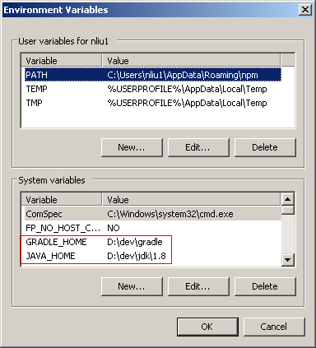

[Checking]

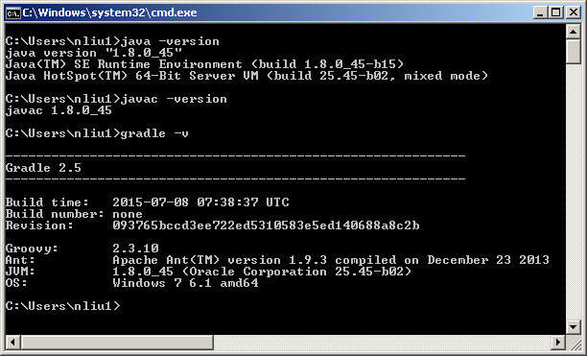

## Install TortoiseSVN and/or CollabNet Subversion client

## Install Eclipse

Download: <https://www.eclipse.org/downloads/index.php>

Installation: <https://wiki.eclipse.org/Eclipse/Installation>

[Notice]

eclipse 4.5(mars) recommanded

eclipse 4.4(luna) and eclipse 4.3(kepler) need a upgrade, details see:

<https://wiki.eclipse.org/JDT/Eclipse_Java_8_Support_For_Kepler>

More Additional Tools(Recommanded)

## Checkout Source Code

1) create a folder as AN root folder(e.g. D:\ActiveNet)

2) checkout ActiveNetServlet(e.g. D:\ActiveNet\ActiveNetServlet)

<https://fndsvn.dev.activenetwork.com/ActiveNet/trunk/ActiveNetServlet>

3) checkout ActiveNetPackage(e.g. D:\ActiveNet\ActiveNetPackage)

<https://fndsvn.dev.activenetwork.com/ActiveNet/trunk/ActiveNetPackage>

4) checkout ActiveNetClients(e.g. D:\ActiveNet\ActiveNetClients)

<https://fndsvn.dev.activenetwork.com/ActiveNet/trunk/ActiveNetClients>

5) checkout gradle-support(e.g. D:\ActiveNet\gradle-support)

<https://fndsvn.dev.activenetwork.com/ActiveNet/core/gradle-support/>

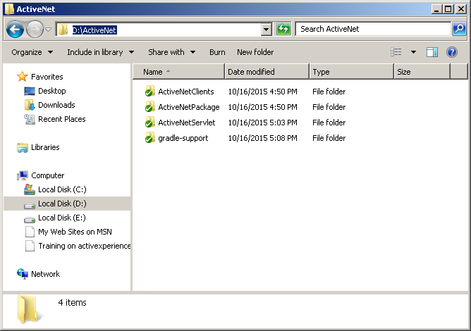

[Notice]

Using Tortoise, checkout <https://fndsvn.dev.activenetwork.com/ActiveNet/trunk> into a root folder (e.g. D:\ActiveNet).It’s OK, but nearly 5G ☺  
  
Xi’an developers: May need to instead copy source code from \\Xian-acrora\AN_Setup\ActiveNet

## Import projects into eclipse

1) open command window(e.g. D:\ActiveNet)

2) execute ‘g cleanEclipse eclipse’ in every projects except ‘gradle-support’, like

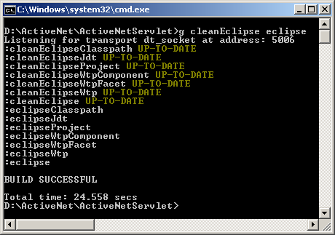

[Notice]

It may take several minutes for downloading dependency

3) Open Eclipse -> File -> Import -> Existing Projects into Workspace ->

Select Root Folder(e.g. D:\ActiveNet) -> Finish

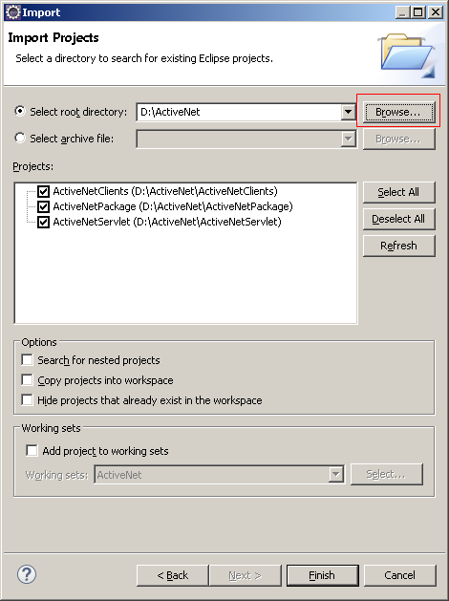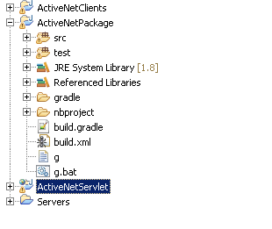

## Install SQL Server

### Update configuration for SQL Server

* SQL Server Configuration Manager
  + 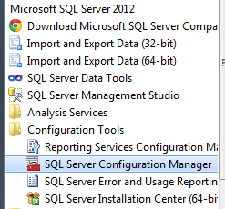
* Enable all TCP\IP settings
  + 
* Create sql admin users “recware” pw: “safari”
* Restart SQL Server

### Restore Databases

* Three databases should be restored: ActiveNetDB, ActiveNetLogs, ActiveNetSites
* The bak files to restore are in \\Xian-acrora\AN_Setup\DB
* The <SourceCodeFolder>/Databases/ActiveNetStartup.bak DB can be restored as ActivenetDB.
* TODO: dev ActiveNetSites.bak and ActiveNetLogs.bak should be put in SVN in <SourceCodeFolder/Databases.

### Upgrade Databases

* Run [SourceCodeFolder]\DBSchema\AnUpsizer.exe to upgrade each DB to the current schemalevel for the ActiveNet application
* Data Dictionary: <SourceCodeFolder>\DBSchema\ActiveNetSites.xml  
  Database: ActiveNetSites

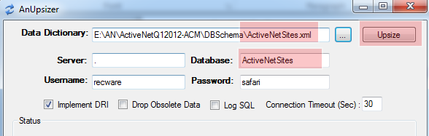

*Ignore error status*

* Data Dictionary: <SourceCodeFolder>\DBSchema\ActiveNetLogs.xml  
  Database: ActiveNetLogs

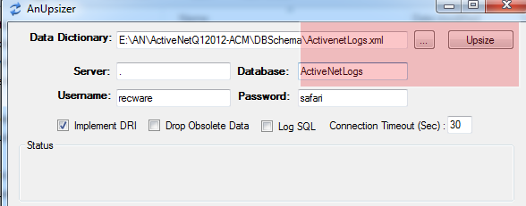

*Ignore error status*

* Data Dictionary: <SourceCodeFolder>\DBSchema\ActiveNetErd.xml  
  Database: ActiveNetDB (this should be the name of the ActiveNet DB that you will be running ActiveNet against, configured in sdi.ini)

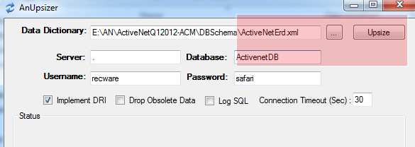

### Additional

In SQL Server SSMS, run <SourceCodeFolder>/DBSchema/LoadCustomizableLists.sql script

## Run with gradle

1) Edit %ROOT_FOLDER%\config\sdi.ini (e.g. D:\ActiveNet\ActiveNetServlet\config\sdi.ini)

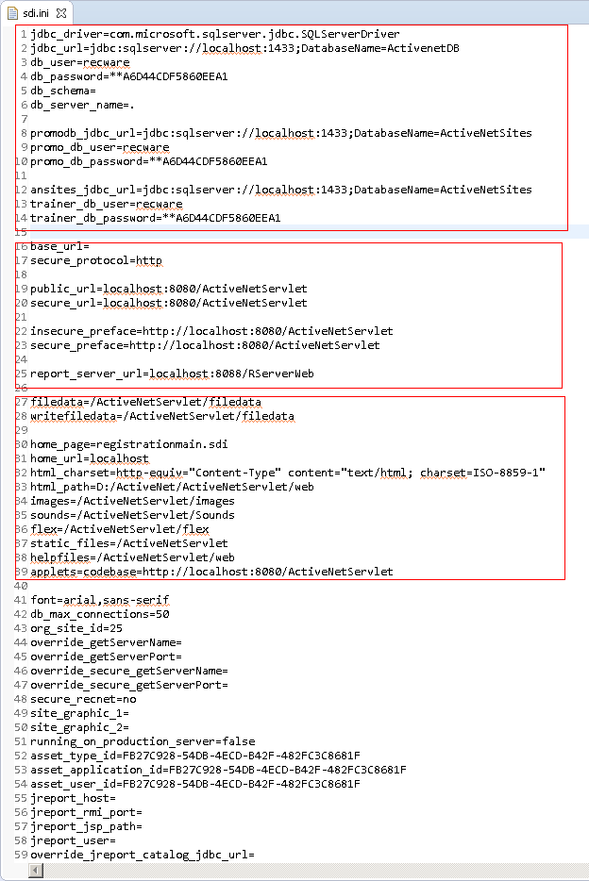

2) Edit web.xml in ActiveNetServlet(e.g. D:\ActiveNet\ActiveNetServlet\web\WEB-INF\web.xml)

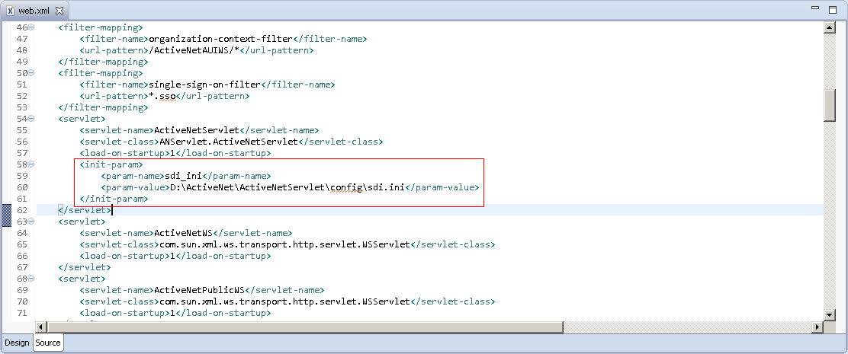

3) execute ‘g run’ in ActiveNetServlet folder(e.g. D:\ActiveNet\ActiveNetServlet)

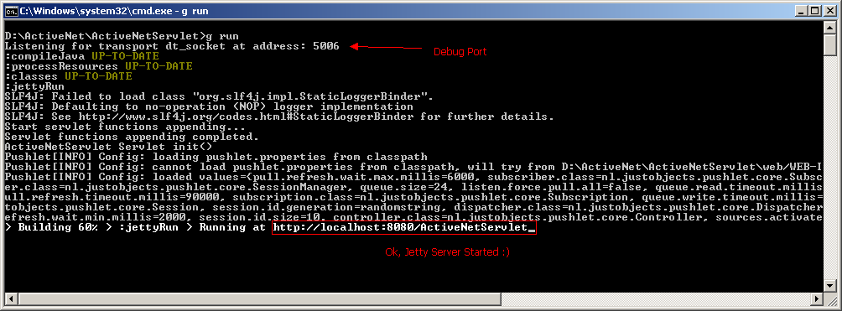

4) access <http://localhost:8080/ActiveNetServlet/adminLogin.sdi> and use recware/safari to login

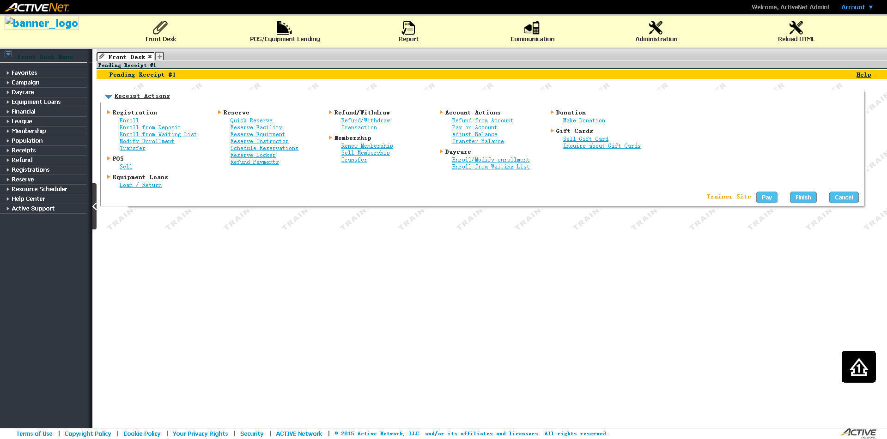

[Notice]

If there are some problem with pages (such as js, images, css, etc), please check sdi.ini, maybe some paths wrong

## Debug with eclipse

Eclipse -> Run -> Debug Configuration -> Remote Java Application(Double-Click To Create New) -> Apply -> Debug -> [Create a breakpoint in ActiveNetServlet.processRequest(…)]

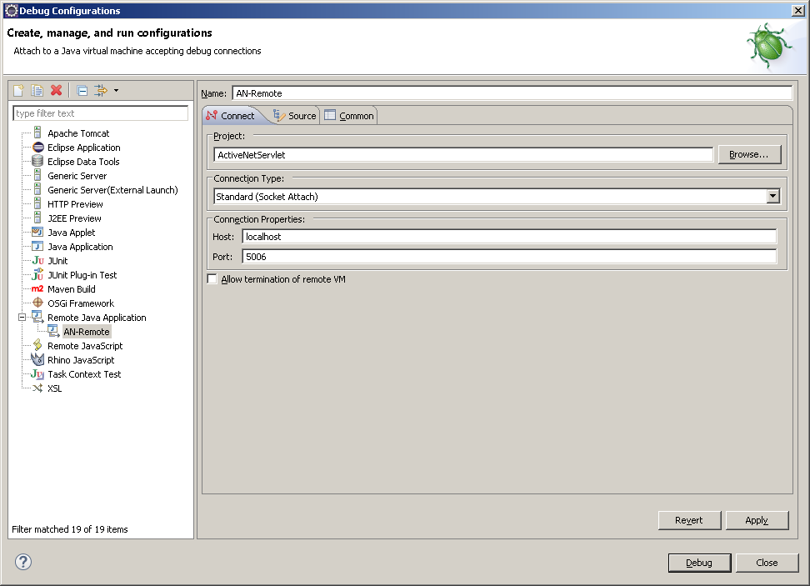

Refresh <http://localhost:8080/ActiveNetServlet/processAdminLogin.sdi>, OK☺

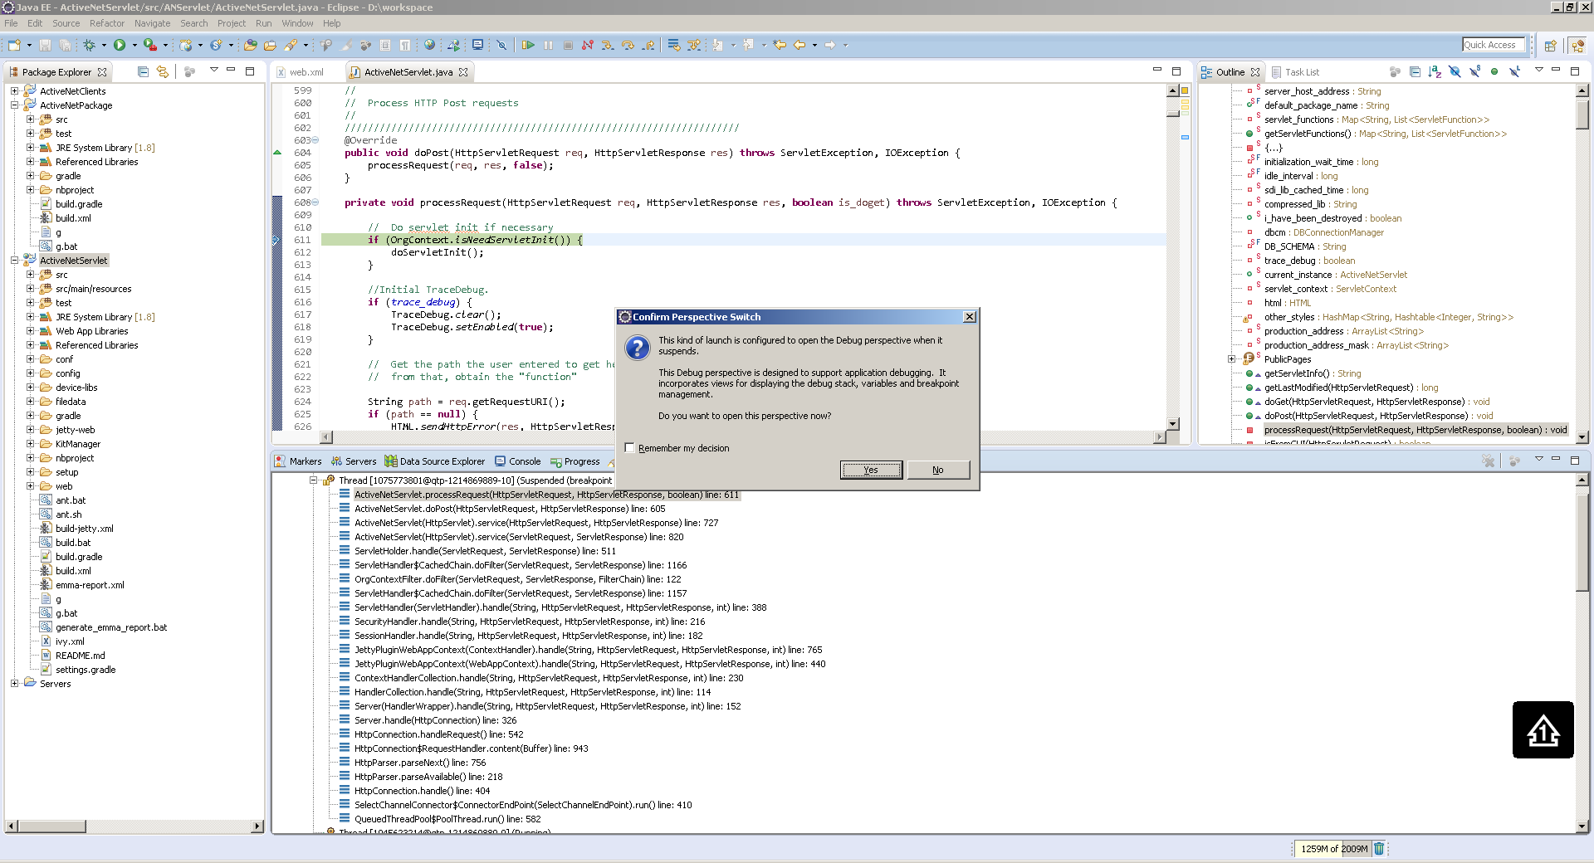

[Notice]

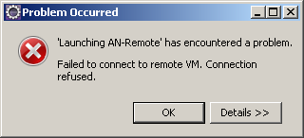

If this dialog shown when click ‘Debug’ button, please check the Debug Port & Debug Protocol, edit g.bat file. (e.g. D:\ActiveNet\ActiveNetServlet\g.bat)

Try to switch debug protocol or change debug port, and then modify the port in Debug Configuration in eclipse.

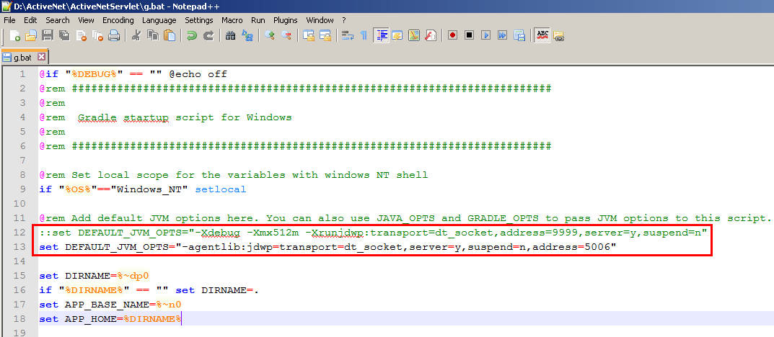

# Additional Tools

## Gradle Suppport

STS: <http://spring.io/tools/sts/all>

Update Sites: <http://dist.springsource.com/release/TOOLS/update/e4.5>

Eclipse > Help > Install New Software… > Add

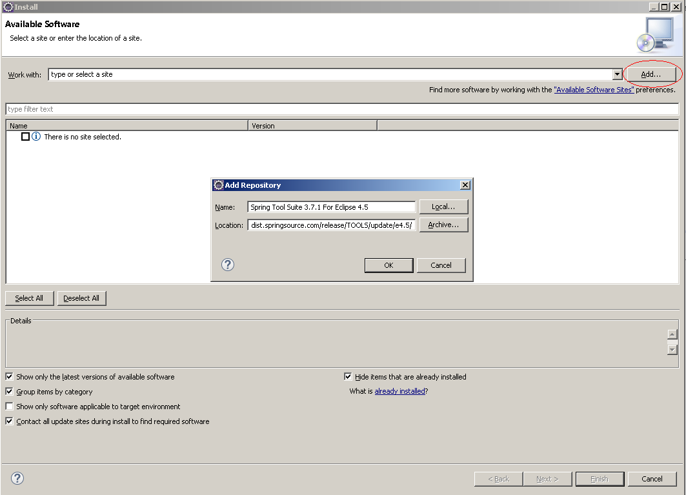

Select Gradle IDE > Next & Finish > Waiting for installing…

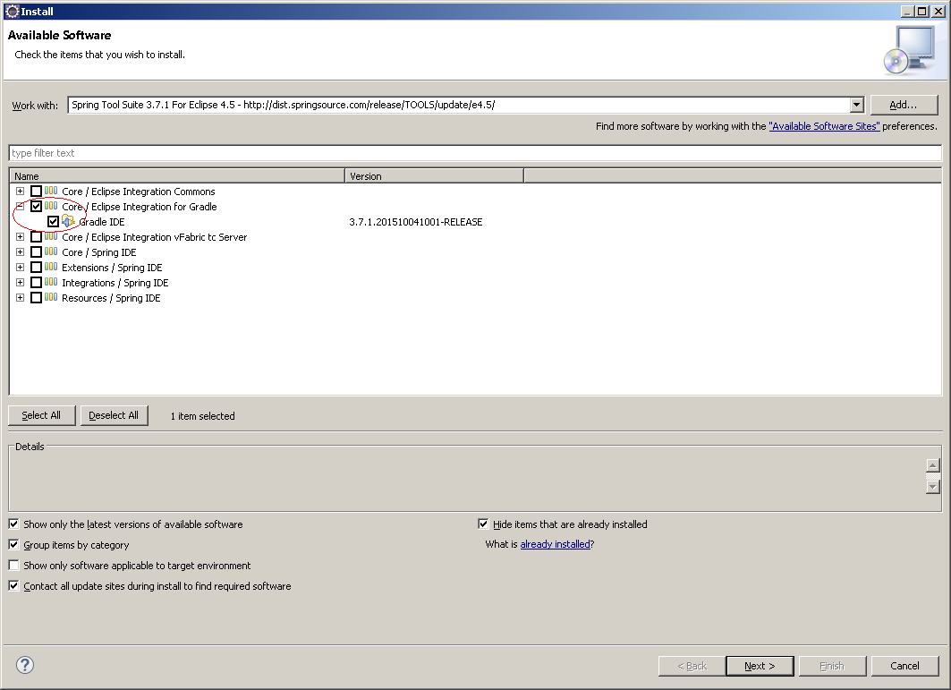

If already imported AN projects by following steps above, use right-click > configure > Convert To Gradle Project, it will convert java-project to gradle-project.

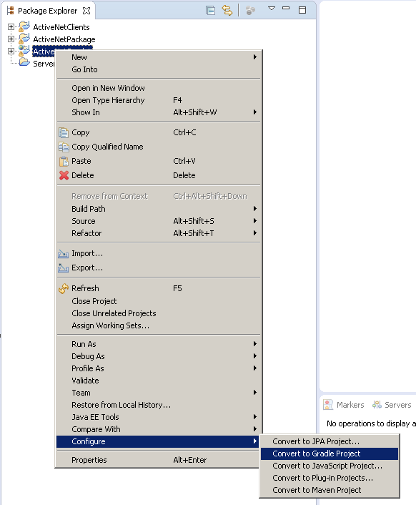

If not, Eclipse > File > Import > Select Gradle Project

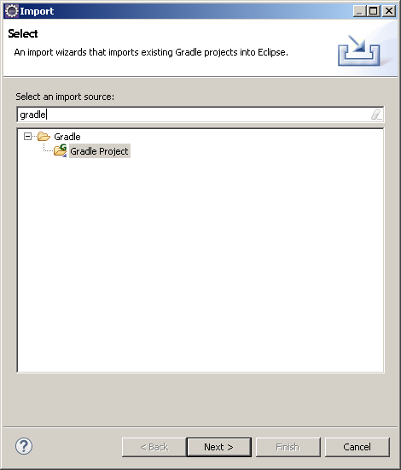

Click ‘Next’ > Select ‘ActiveNetServlet’ Project > Click ‘Build Model’

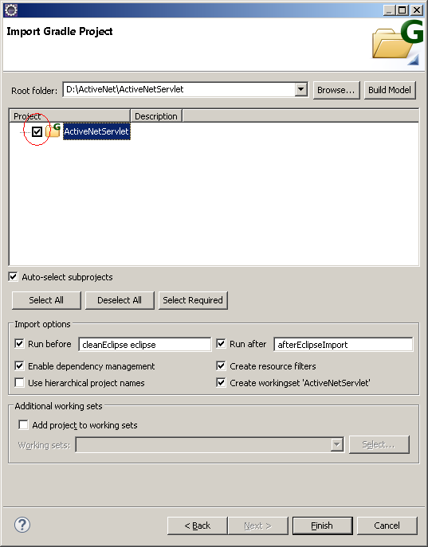

Click ‘Finish’,OK. (Import ‘ActiveNetPackage’ & ‘ActiveNetClients’ same way)

### Gradle Plugin Usage

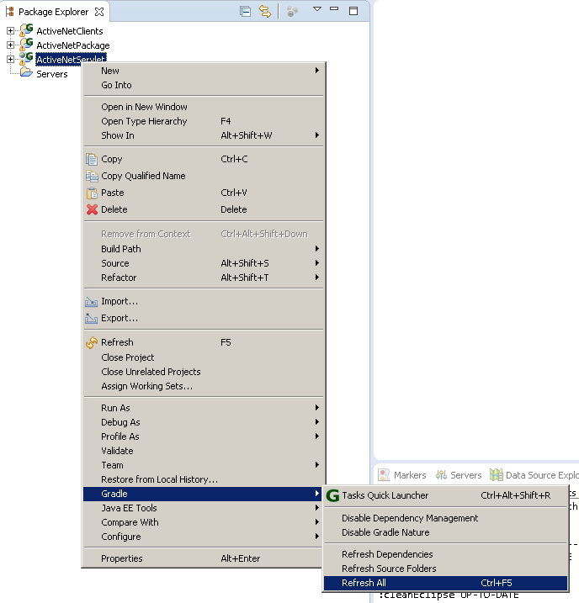

On this menu,

1) click ‘Refresh All’ to refresh build path after build.gradle changed (code change, upgrade from svn, etc…)

2) click ‘Tasks Quick Launcher’ to execute gradle command (Not Debug!)

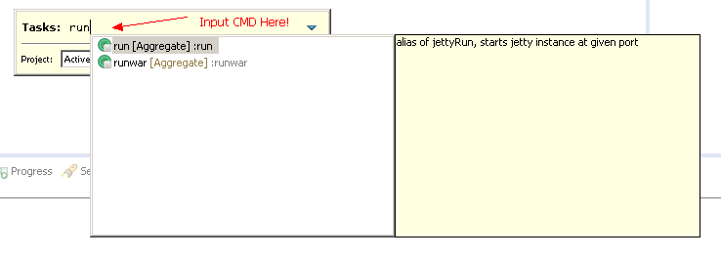

Console View:

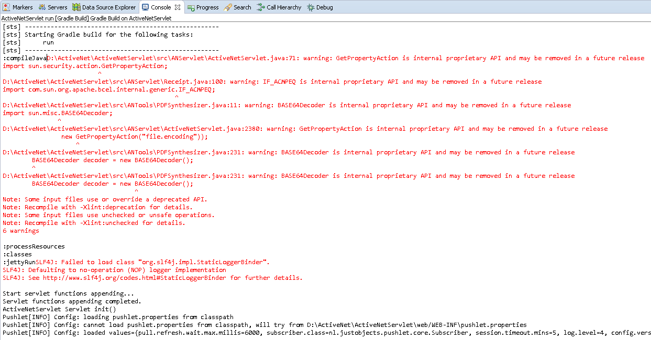

### Run & Debug with eclipse

1) Right-Click > Run As > Grade Build…

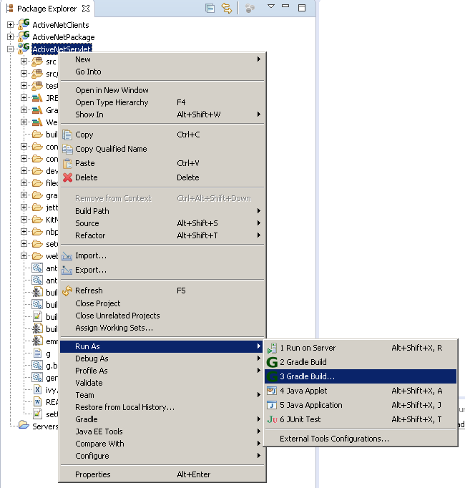

2) Setup Command

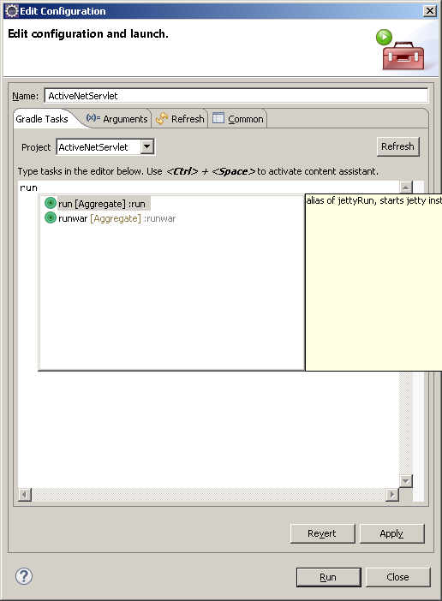

3) Setup Arguments

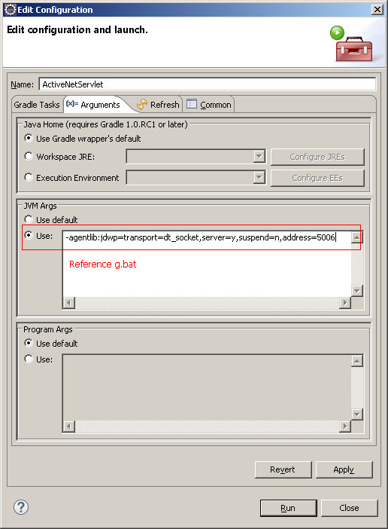

4) Save Launcher File

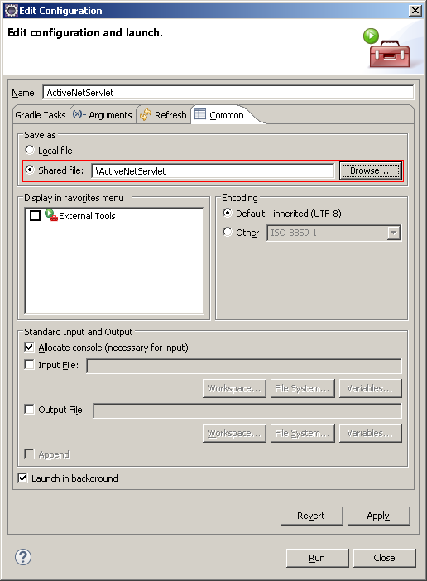

5) Click ‘Apply’ -> Run

Console View same to above☺

You will find a launch file created in ‘ActiveNetServlet’

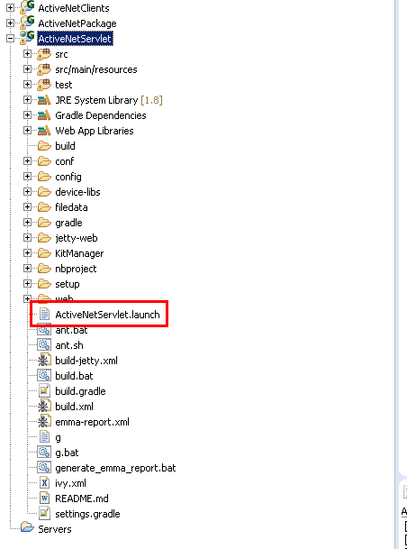

So, you can use it☺

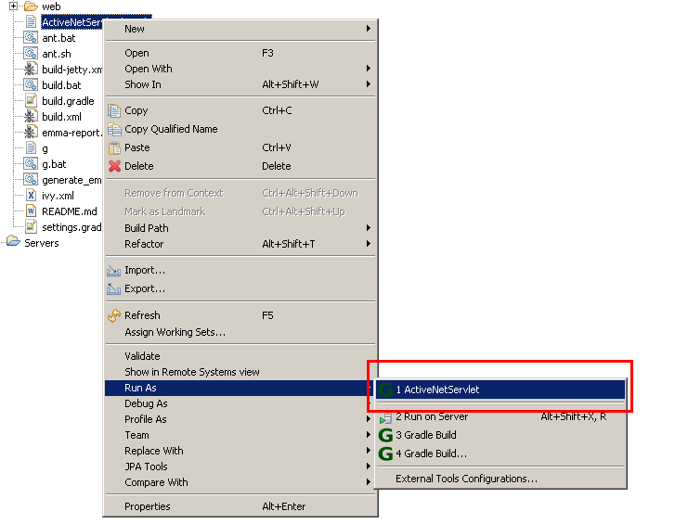

6) Use Existing Debug Configuration (Reference)

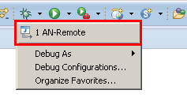

### How debug ActiveNetServlet if breakpoint in ActiveNetPackage?

Edit ActiveNetServlet/build.gradle

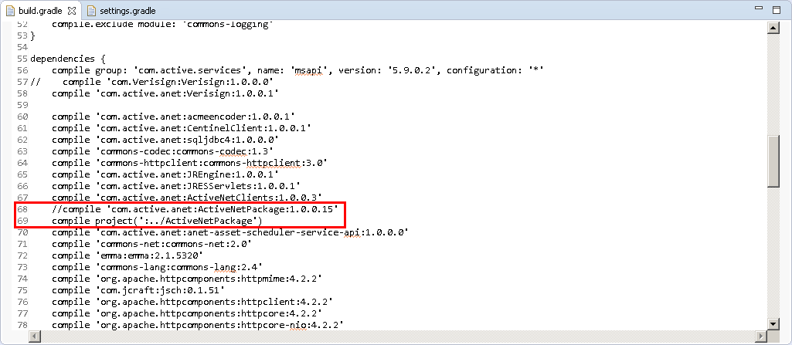

Edit ActiveNetSerlvet/settings.gradle

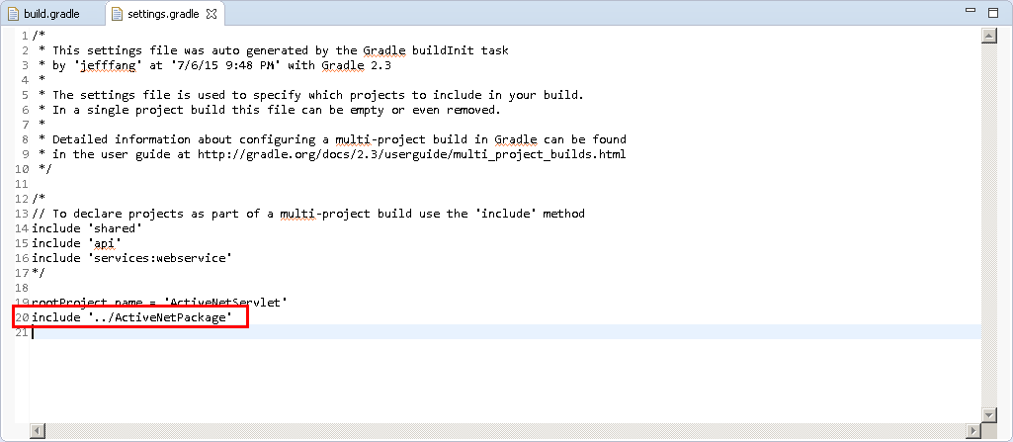

Refresh ActiveNetServlet and Run (Create a breakpoint in ActiveNetPackage), don’t forget starting Debug (AN-Remote)

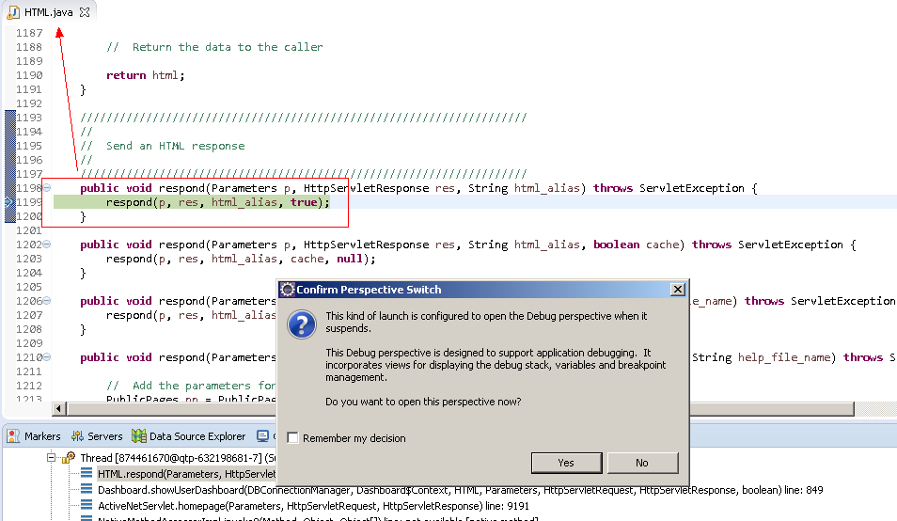

**[Important Notice]**

**Don’t submit this change into SVN, it will break the CI building maybe. Just use it local, thanks☺**

## Subversion Support

Use Eclipse Marketplace Client to install it.

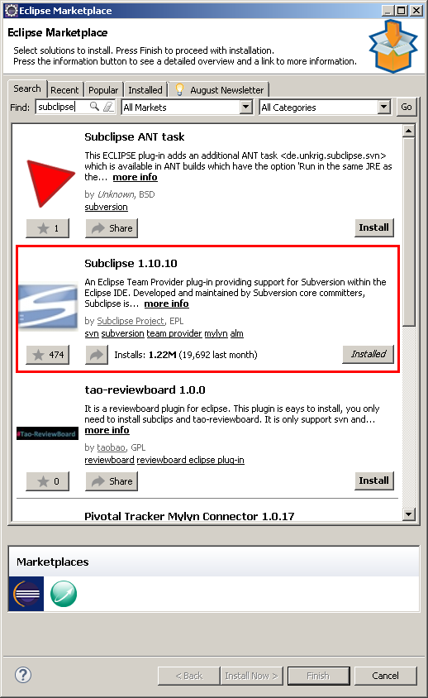

Right-Click > Team > Share Project…

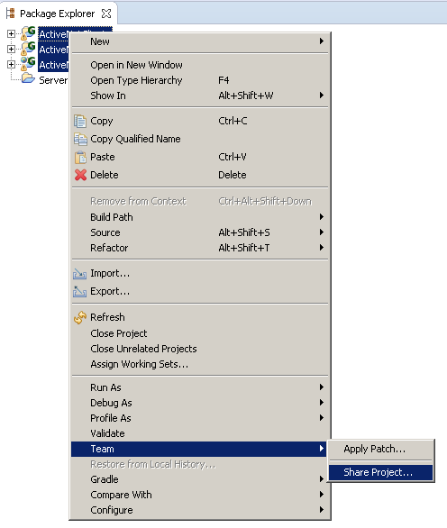

Select SVN > Next

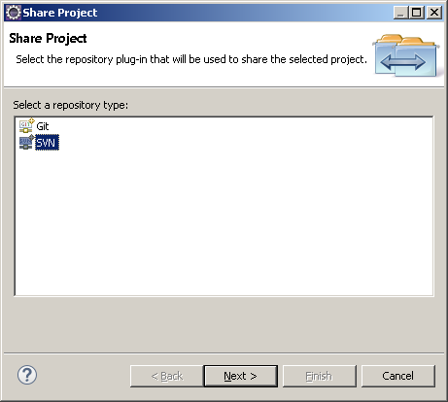

Select Project > Share Project

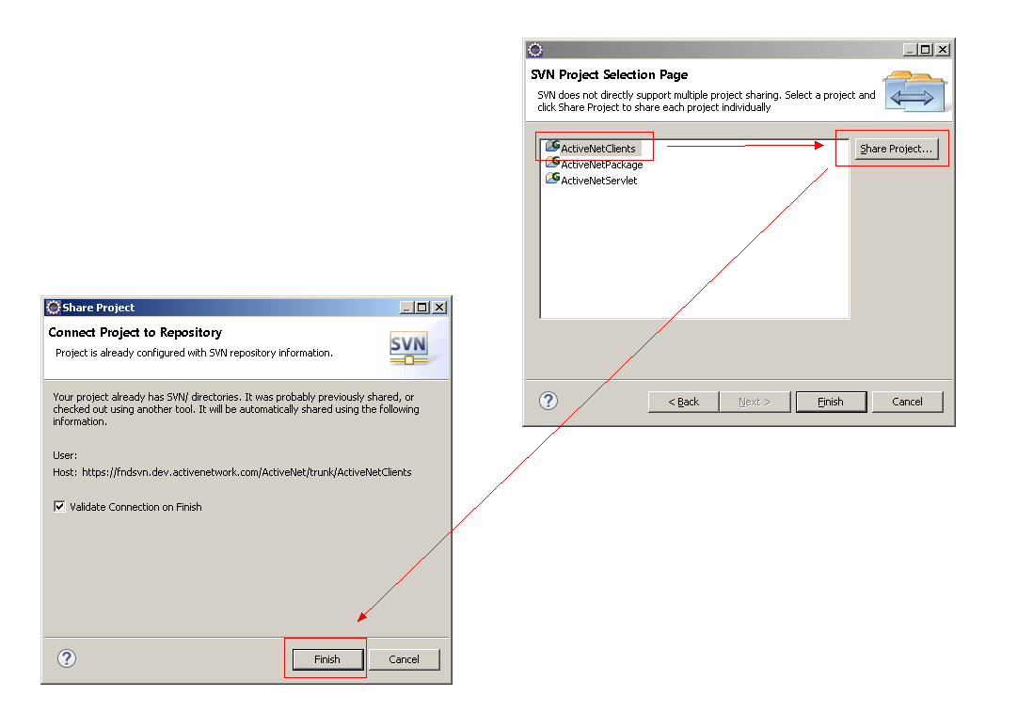

Click ‘Finish’, after all project shared.

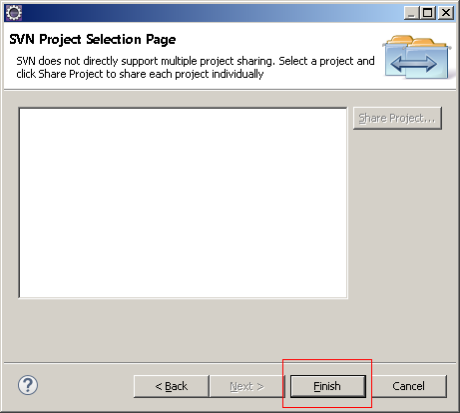

Right-Click > Team

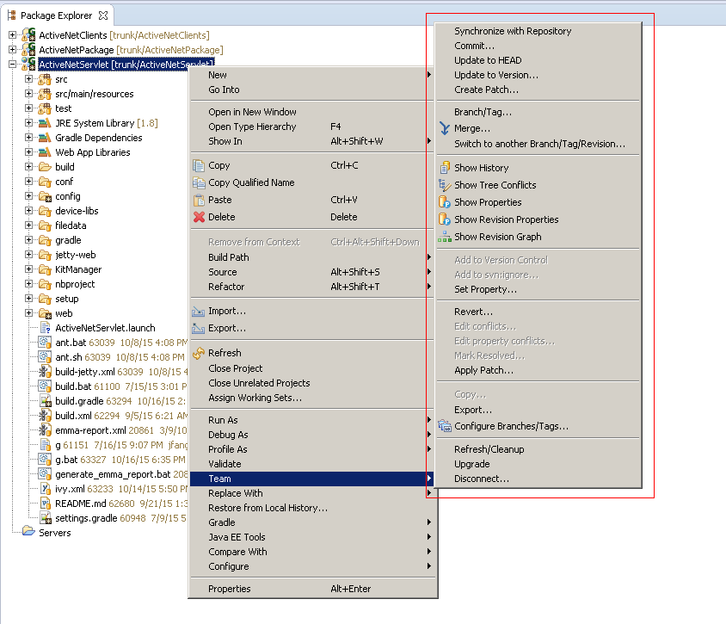

# Setup Report Server

1. Report Server is VB application used to run ActiveNet static (“canned”) reports. This is different from Jasper Reports and JReports, which support dynamic adhoc reports.
2. Install VS2005, path is \\wsfscn01\Tools\Visual Stuido\Visual Studio 2005 Team Edition (include three ISO file and one SP1)
3. Install Active Report (your source code\Third Party Stuff\ActiveReports)
4. Open IIS, Selected ***Default Web Site*.** change Port to 8088 and start this site

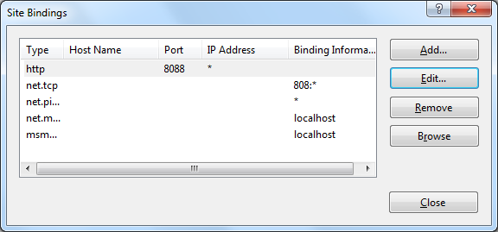

1. Create a new Application belong to you ***Default Web Site***. (Please pay attention on Alias and Physical path)

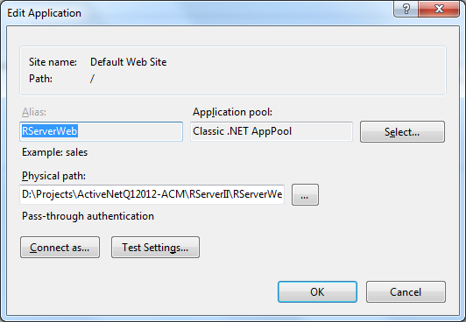

1. Create new Application Pool

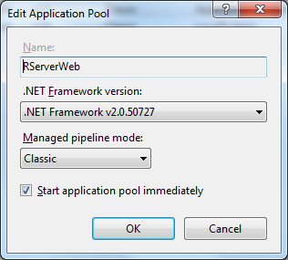

1. Change Application pool of RServerWeb.

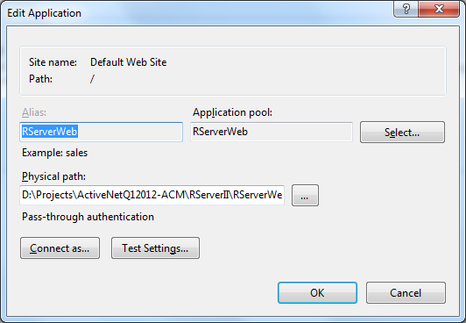

1. Config [SourceCodeFolder]\sdi.ini

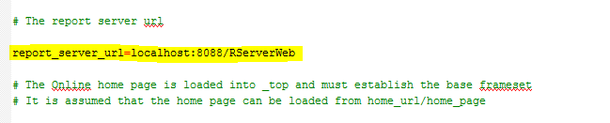

1. Change file [SourceCodeFolder]\RServerII\RServerII.sln



[Notice]

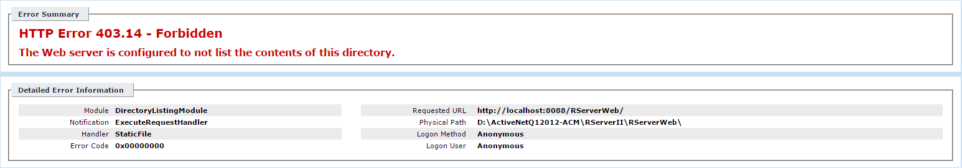

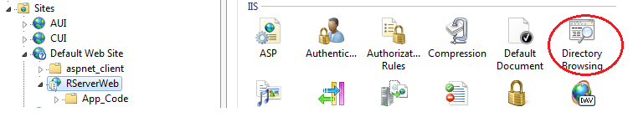

Enable Directory Browsing

[Notice]

If can’t open “http://localhost:8088/RServerWeb/RServer.aspx”

%windir%\Microsoft.NET\Framework\v2.0.50727\aspnet_regiis.exe -i

64-bit:

%windir%\Microsoft.NET\Framework64\v2.0.50727\aspnet_regiis.exe -i

**Notice**

If it popup “Unable to open the Web 'http://localhost/*project name*'. The Web server does not appear to have the FrontPage server extensions installed.” when you try to open project via vs2005. Please refer <http://support.microsoft.com/kb/936857> to resolution it.